 | Course Name: Design Patterns/Thinking LAB | EXPERIMENT NO. 8
 | Course Code: 20CP210P  Faculty: Dr. Ketan Sabale | Branch: CSE | Semester: IV
(To be filled by Student)
Submitted by: Manan Kapkar
Roll no:23BCP336

Objective: To familiarize students with standard Creational design patterns.
Experiment: Explain the adapter design pattern and write a program using any object-oriented programming language to demonstrate the working of adapter design pattern.
Adapter Design Pattern
- The Adapter Design Pattern is a structural pattern that allows incompatible interfaces to work together. It acts as a bridge between two incompatible interfaces, enabling classes with incompatible interfaces to collaborate without changing their source code.
- An Adapter wraps an existing class (the adaptee) with a new interface (the target interface) expected by the client. It translates method calls from the client into calls to the adaptee in a compatible format.

Structure:
- Target: The interface expected by the client.
- Adaptee: The existing class that needs adapting.
- Adapter: Implements the target interface and translates calls to the adaptee.

Advantages
- Promotes reusability: Allows you to use existing classes even if they don't match the expected interface.
- Improves flexibility: You can adapt multiple incompatible classes to work with your system without modifying them.
- Decouples client and implementation: Clients interact with the target interface, not the adaptee.
- Follows Open/Closed Principle: You can extend system functionality without modifying existing code.

Disadvantages
- Increased complexity: Adds extra layers in the system, which might make it harder to understand.
- May reduce performance: Due to extra indirection in method calls.
- Overuse can lead to messy code: Using too many adapters can make the architecture hard to maintain.
- Not always suitable: If adapting requires too much transformation, it may be better to redesign the system.
Class Diagram:
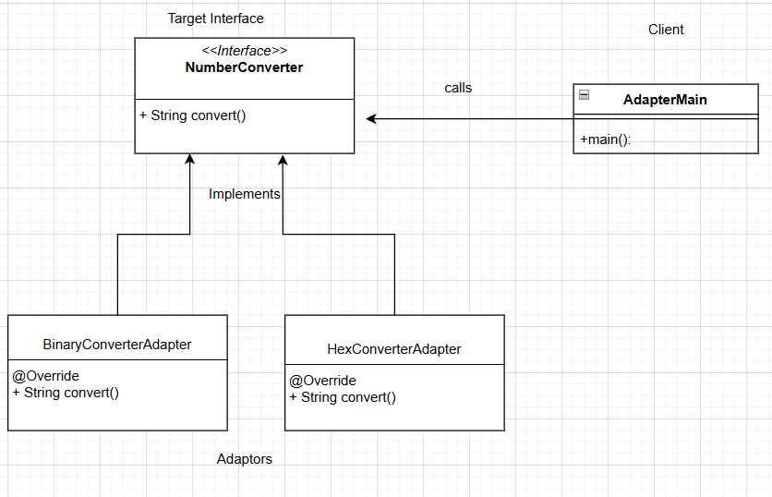

Code:

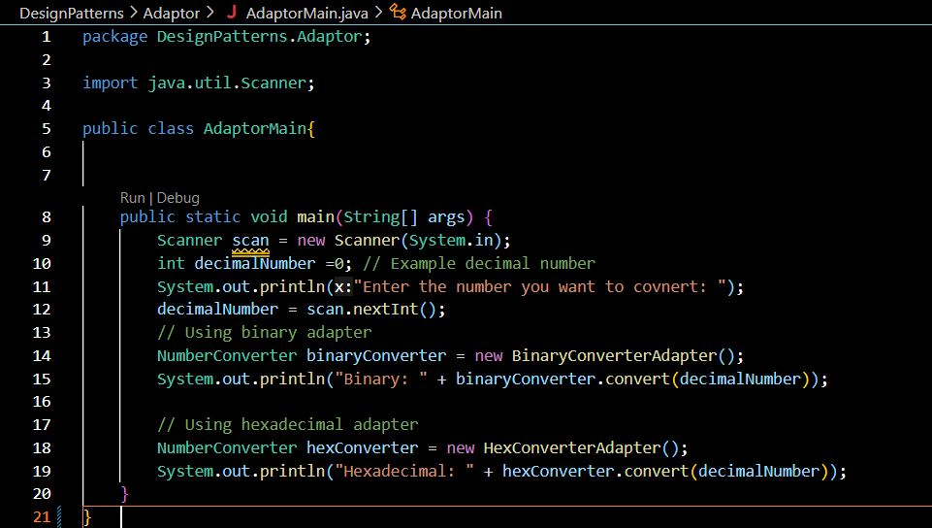
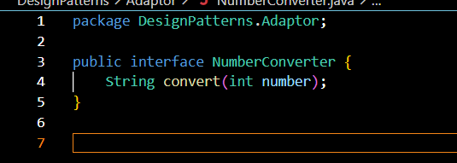
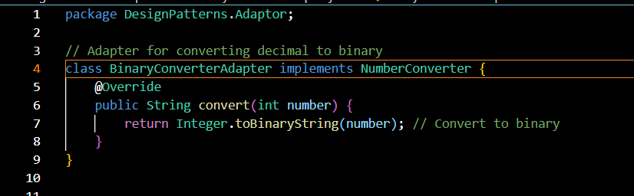
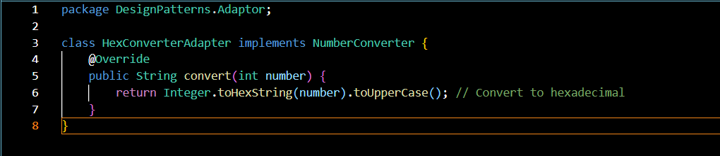
Output:
